Spreading the word about an opportunity for local women to learn about opportunities in the union building trades, and meet real tradeswomen on our panel of speakers. Feel free to share with your networks.

**Central MA Tradeswomen Tuesday**

October 20th

5-6 pm

on Zoom

All are welcome

Register here: <https://bit.ly/3iTEoSn>

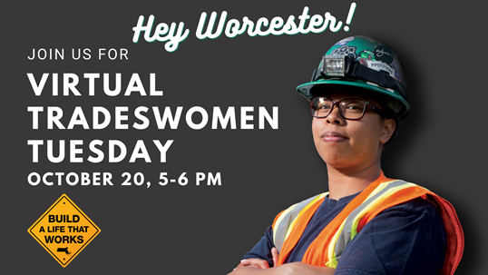

**Kate Harrison Leon**  
Program Director

Northeast Center for Tradeswomen's Equity   
857 800 8881  
#20percentby2020