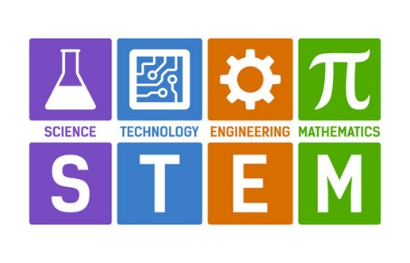
QCC STEM Students
Are you transferring to a Massachusetts State University?
Check out these FREE Summer Programs.

Students transferring from one of the fifteen community colleges in Massachusetts and transferring to any public 4-year university to pursue a bachelor’s degree
in a STEM field are welcome to apply to Summer Transfer Academy program. These programs will either run in-person or virtually,
depending on the status of social distancing and campus policy at that time.

Click on the link below to access the website:
Details for each school is located at the bottom of the webpage.
https://www.mass.edu/strategic/stem_transferacademy.asp
- Have fun!
- Meet other STEM transfer students!
- Develop relationships with campus faculty and staff!
- Take a free class that applies to your major!
- Know where and how to access key resources on campus!

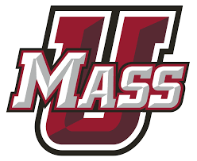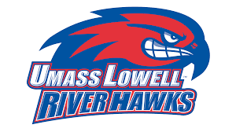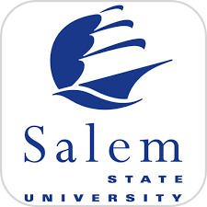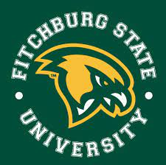

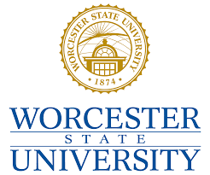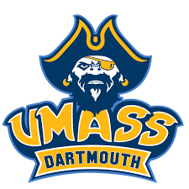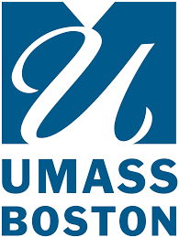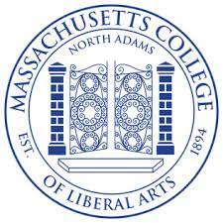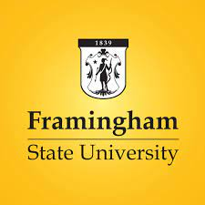

The 2023 Summer STEM Transfer Academy application is now live, and students can check individual university program information for specific application deadlines? In the interim, please reach out to Allison Little alittle@dhe.mass.edu, Assistant Commissioner of P16 Alignment and Outreach, with questions.

