**Initials Incorrect:**

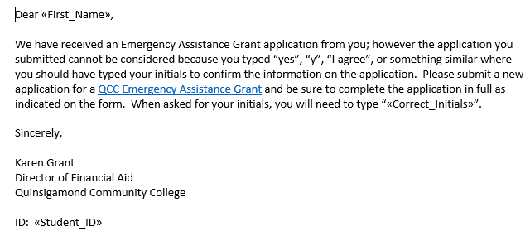

**Amount:**

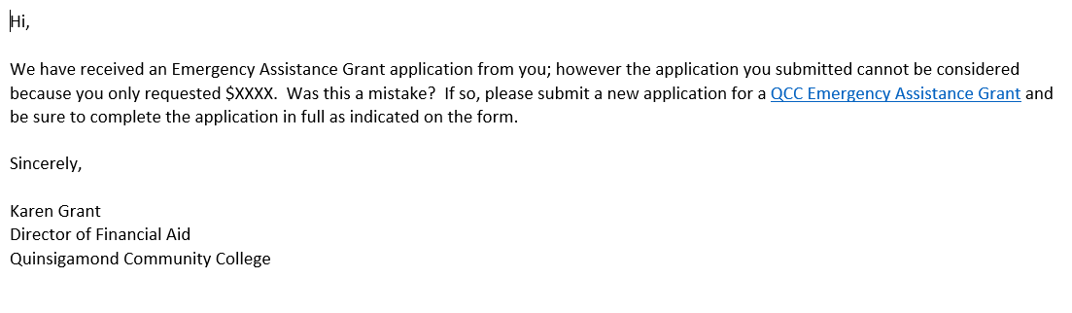

**Exceptional Need**:

