Adding the Subject Tutoring Blackboard link to your course - Fall 2023
This job aid will provide instructions on how to add a direct link to the Subject Tutoring Blackboard course in your course.
NOTE: This link changes each semester and will need to be recreated or edited in your courses.

Follow the below steps:
- Log into the Blackboard course where you would like to add the link to Subject Tutoring

- In the upper left hand corner of the window, click on the Add Menu Item icon and then click on

Web Link

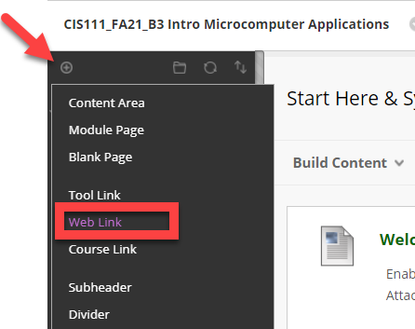
- Type in a name for the link, and then copy the below URL into the URL text box for Fall 2023 Only: https://mycourses.qcc.edu/ultra/courses/_79646_1/cl/outline
- Be sure to check the Available to Users box so students can view and access the link

- Click Submit

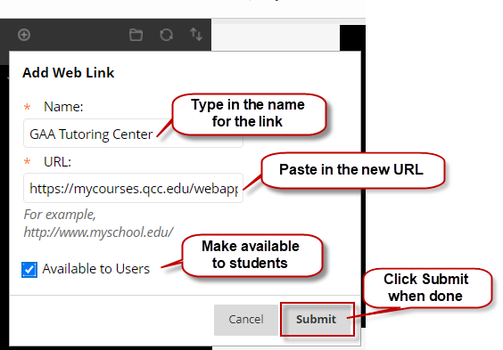

Adding the Subject Tutoring link to your course (cont.)
- Once you have created the link, remember that it will be at the bottom of the student links in the left side navigation area. If you want to move it up, just click to the left until you see the move pointer, click and hold and drag to where you want it.
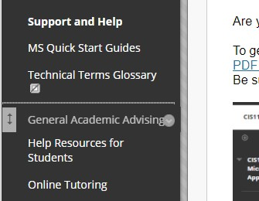

- The last step is to have the Subject Tutoring course open in a new window, so it doesn't redirect students out of yourcourse.
- Click the arrow to the right of the newly added Subject Tutoring link and a context menu will appear.
- Click on Set Link to Open in a New Window

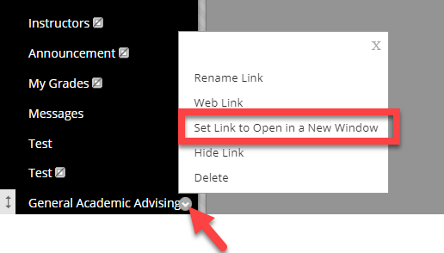

NOTE: This link will not work for instructors as you are not enrolled in the Subject Tutoring course, but it will work for students who are enrolled.

  - When the student clicks on the link, it will open another browser window as shown below

