Adding the General Academic Areas (GAA) Tutoring Center Blackboard link to your course - Spring 2022
This job aid will provide instructions on how to add a direct link to the GAA Blackboard course in your course.
NOTE: This link changes each semester and will need to be recreated or edited in your courses.

Follow the below steps:
- Log into the Blackboard course where you would like to add the link to the GAA

- In the upper left hand corner of the window, click on the Add Menu Item icon and then click on

Web Link

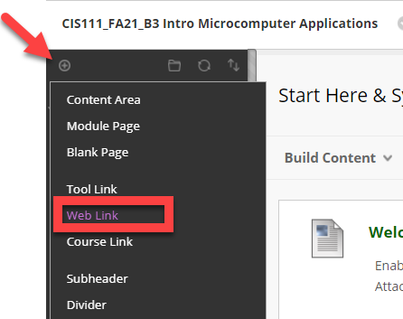
- Type in a name for the link, and then copy the below URL into the URL text box for Spring 2022 Only:
https://mycourses.qcc.edu/webapps/blackboard/execute/announcement?method=search&context=course&course_id=_62449_1&handle=cp_announcements&mode=cpview
- Be sure to check the Available to Users box so students can view and access the link

- Click Submit

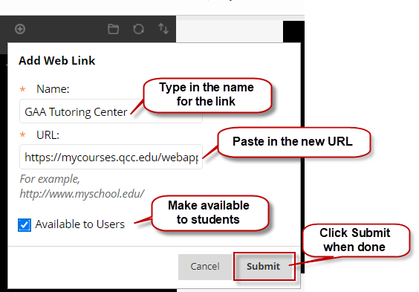

Adding the General Academic Areas (GAA) Tutoring Center link to your course (cont.)
- Once you have created the link, remember that it will be at the bottom of the student links in the left side navigation area. If you want to move it up, just click to the left until you see the move pointer, click and hold and drag to where you want it.
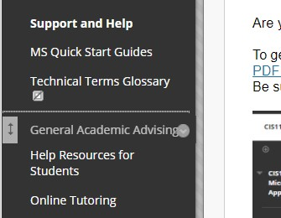

- The last step is to have the GAA course open in a new window so it doesn't redirect students out of your course.
- Click the arrow to the right of the newly added GAA link and a context menu will appear
- Click on Set Link to Open in a New Window

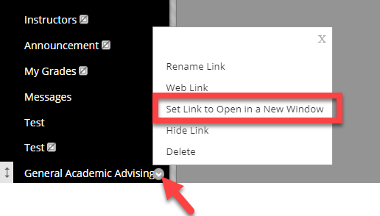

NOTE: This link will not work for instructors as you are not enrolled in the GAA course, but it will work for students who are enrolled.

  - When the student clicks on the link, it will open another browser window as shown below

