STEM Starter Academy would like to invite students to attend the
Undergraduate Research Conference at UMass Amherst
QCC will provide transportation to and from the conference.
Date: Friday, April 24, 2020
Lincoln Campus Center @ UMASS Amherst
Time: 8:00am – 5:00pm “FREE”
A coach bus will pick up students at the main campus in Worcester at 7:45am and leave UMASS at 3:30pm to go back to QCC Worcester campus.

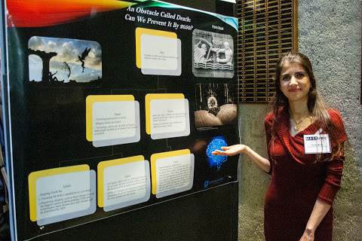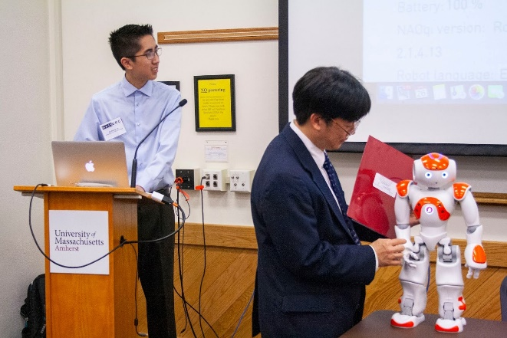

You will have the opportunity to view amazing research projects from undergraduate students with diverse backgrounds from universities, colleges, and community colleges across the Commonwealth of Massachusetts. Network!
Limited seats available. Contact Darcy Carlson if you would like to attend.
Click here for conference information

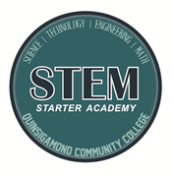

Darcy Carlson
STEM Starter Academy Project Coordinator
508-854-4441
dcarlson@qcc.mass.edu

Funded by the STEM Starter Academy

